# Manual of Data Visualizer project

Hi, welcome to use the Data Visualizer demo project made by Yuwei.

## Log in

Firstly, enter the address will lead to a login page, the demo instance could be logged in with account admin and password 111111.

## Main page

There are 2 parts to the main page: the “Big screen” dashboard and the popular folders.

Users can set any of the dashboards as the one displayed on the main page. The popular folders are the most recently viewed folders by the user.

### See all folders.

Click “See All” button and it will jump to the “All folders” page.

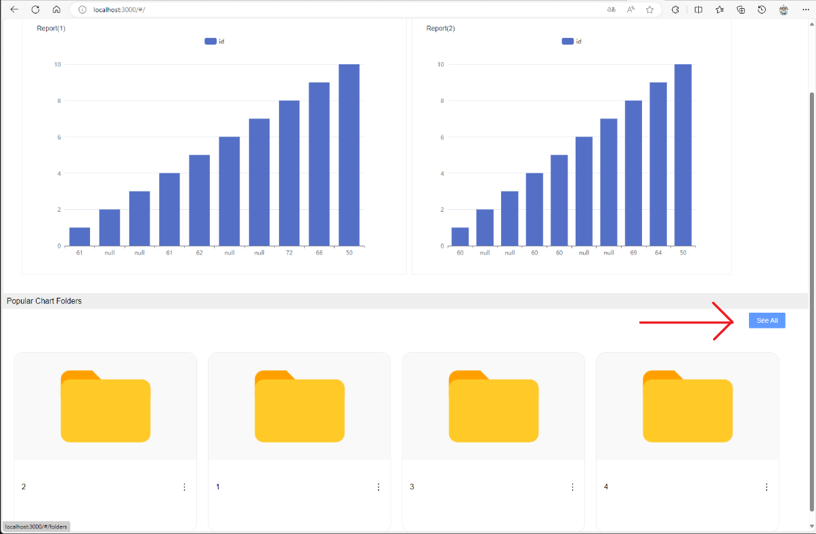

You can go back to the main page anytime by clicking the “home” icon in the bread crumb.

## Create a folder

By clicking “Create a folder” can user create a folder.

Then it could be edited (rename or add a description) or deleted.

As an example, we created a folder and renamed it as something like “Air quality in Oslo”

Then it should be like this.

Entered the folder, there are 2 tabs: dashboards and data sources. We need to add data sources and then create dashboards based on those data sources.

## Upload a data source file.

Switch to data sources tab and click “Create a datasource”.

Select excel or csv. The demo instance may only support excel files. But in theory it could support any text-based file, or databases.

Select file and upload it.

## Review the data.

When a data is uploaded, it could be opened and reviewed.

## Create a dashboard.

Switch to Dashboards tab and create a dashboard

## Rename and add description to dashboard.

Click edit and the basic info of dashboards could be edited.

## Design the dashboard.

Open the dashboard, and then we can add different charts to the dashboard. The charts could be dragged and zoomed.

## Add a chart to the dashboard.

Select a component type in the drop-down menu and fill with the dimensions and measures. The heatmap has 3 measures: longitude, latitude and density.

Rename it and click “Done”.

## Keep adding reports or save the dashboard.

You can add more reports. If you want to save the dashboard, click “Save” on the upper right area.

## Set a dashboard to the main screen.

You can set dashboard as the “Big screen” of the index page.

## View the main screen with the “Big screen” dashboard.

## You can still go to the folders to explore more

Enjoy the exploration!

The software is fully designed by Yuwei Tong. Tested by Yuwei Tong and Lai Wei.

Project: [Nyakoonya/Demo (github.com)](https://github.com/Nyakoonya/Demo) and [Nyakoonya/Demo-backend (github.com)](https://github.com/Nyakoonya/Demo-backend)